INDIVIDUAL ASSIGNMENT

ARIANA ROCHA (Andrew ID: afrocha)

DUE: 23 SEP 2024

**Phase 2: Exploratory Data Analysis (EDA) on Time Series Data (25 Points)**

Objective: Perform EDA on the data streamed from Kafka, focusing on understanding the temporal patterns in the traffic flow data.

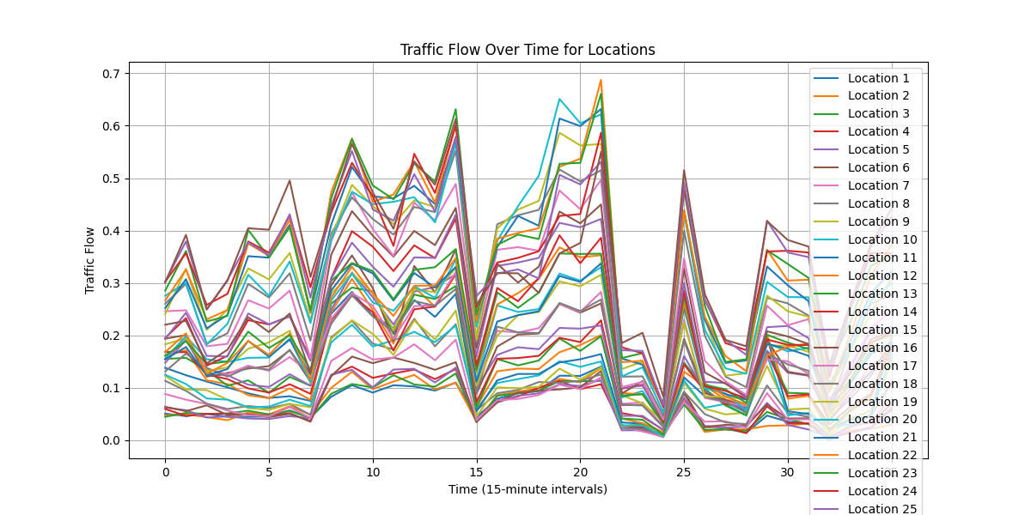

Explanation: Graph plots traffic data patterns over the last 450 minutes that coincide with expected traffic flow. There are noticeable decreases in traffic flow at the 15 and ~20 increment marks likely depicting phenomenon consistent with rush hour patterns.

**Phase 3: Basic Traffic Flow Prediction (35 Points)**

**Objective:** Develop a simple predictive model to forecast traffic flow using the features derived from the time-series data